Week 3 Day 3 : Morning
Data visualization with python

While working with data, it can be difficult to truly understand your data when it’s just in tabular form. To understand what exactly our data conveys, and to better clean it and select suitable models for it, we need to visualize it or represent it in pictorial form. This helps expose patterns, correlations, and trends that cannot be obtained when data is in a table or CSV file.

What is Data Visualization?
- Data visualization is a field in data analysis that deals with visual representation of data. It is a concept of graphical representation of data or information using visual elements like graphs, charts, and maps.
- This representation helps us in understanding the patterns, trends, and outliers in the data and it makes data easily understandable and explainable.
- With the increase in the volume of data, discovering the patterns in data has become challenging.
- By making use of data visualization, a huge chunk of complex data can be displayed in a way that is easy to understand and is also appealing to the eyes.
- Using data visualization, we can get a visual summary of our data.
- With pictures, maps and graphs, the human mind has an easier time processing and understanding any given data.
- Data visualization plays a significant role in the representation of both small and large data sets, but it is especially useful when we have large data sets, in which it is impossible to see all of our data, let alone process and understand it manually.

Coordinate Systems and Axes
To make any sort of data visualization, we need to define position scales, which determine where in a graphic different data values are located. We cannot visualize data without placing different data points at different locations, even if we just arrange them next to each other along a line. For regular 2D visualizations, two numbers are required to uniquely specify a point, and therefore we need two position scales. The combination of a set of position scales and their relative geometric arrangement is called a coordinate system.

Cartesian Coordinates
- The most widely used coordinate system for data visualization is the 2D Cartesian coordinate system, where each location is uniquely specified by an x and a y value.
- The x and y axes run orthogonally to each other, and data values are placed in an even spacing along both axes (Figure 3-1). The two axes are continuous position scales, and they can represent both positive and negative real numbers.
- To fully specify the coordinate system, we need to specify the range of numbers each axis covers.
- The horizontal axis is conventionally called x and the vertical axis y.
- The two axes form a grid with equidistant spacing. Here, both the x and the y grid lines are separated by units of one. The point (2, 1) is located two x units to the right and one y unit above the origin (0, 0). The point (–1, –1) is located one x unit to the left and one y unit below the origin.
Standard Cartesian coordinate system
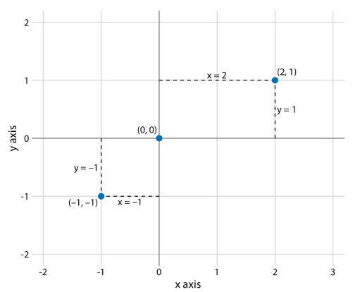
- Data values usually aren’t just numbers, however. They come with units. For example, if we’re measuring temperature, the values may be measured in degrees Celsius or Fahrenheit. Similarly, if we’re measuring distance, the values may be measured in kilometres or miles, and if we’re measuring duration, the values may be measured in minutes, hours, or days.
- In a Cartesian coordinate system, the spacing between grid lines along an axis corresponds to discrete steps in these data units. In a temperature scale, for example, we may have a grid line every 10 degrees Fahrenheit, and in a distance scale, we may have a grid line every 5 kilometres.
- A Cartesian coordinate system can have two axes representing two different units. This situation arises quite commonly whenever we’re mapping two different types of variables to x and y.
- For example, in the below Figure, we have plotted a graph showing temperature versus days of the year. The y axis is measured in degrees Fahrenheit, with a grid line every at 10 degrees, and the x axis is measured in months, with a grid line at the first of every third month.
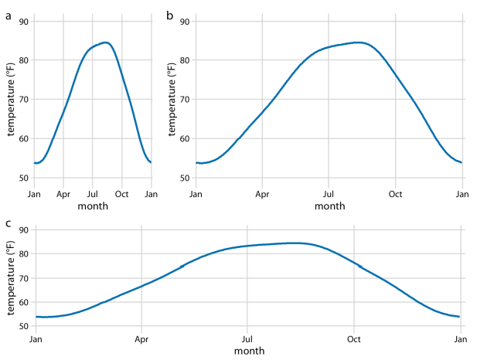
- Whenever the two axes are measured in different units, we can stretch or compress one relative to the other and maintain a valid visualization of the data. Which version is preferable may depend on the story we want to convey. Ideally, we want to choose an aspect ratio that ensures that any important differences in position are noticeable.
- On the other hand, if the x and y axes are measured in the same units, then the grid spacings for the two axes should be equal, such that the same distance along the x or y axis corresponds to the same number of data units. As an example, we can plot the temperature in Houston, against the temperature in San Diego, for every day of the year. Since the same quantity is plotted along both axes, we need to make sure that the grid lines form perfect squares,
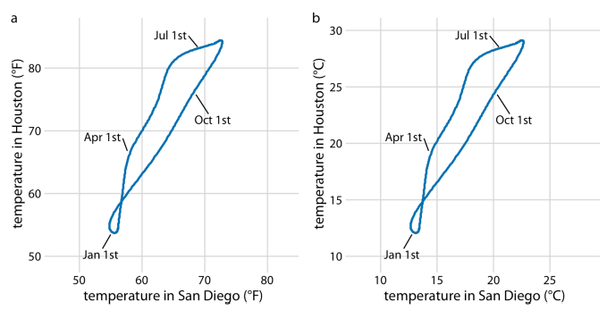

- A change in units is a linear transformation, where we add or subtract a number to or from all data values and/or multiply all data values with another number. Fortunately, Cartesian coordinate systems are invariant under such linear transformations. Therefore, you can change the units of your data and the resulting figure will not change as long as you change the axes accordingly. As an example, compare above figures. Both show the same data, but in part (a) the temperature units are degrees Fahrenheit and in part (b) they are degrees Celsius. Even though the grid lines are in different locations and the numbers along the axes are different, the two data visualizations look exactly the same.

Directory of Visualizations
Amounts
The most common approach to visualizing amounts (i.e., numerical values shown for some set of categories) is using bars, either vertically or horizontally arranged. However, instead of using bars, we can also place dots at the location where the corresponding bar would end.
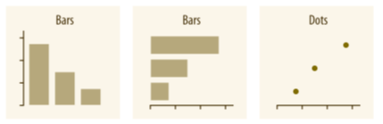
If there are two or more sets of categories for which we want to show amounts, we can group or stack the bars. We can also map the categories onto the x and y axes and show amounts by color, via a heatmap
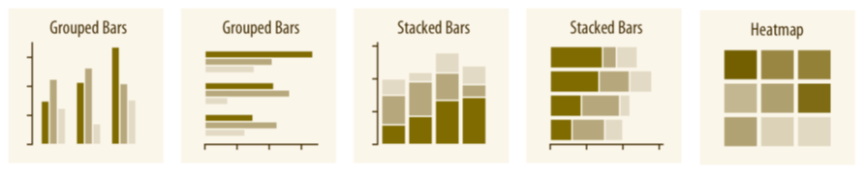

Distributions
- Histograms and density plots provide the most intuitive visualizations of a distribution, but both require arbitrary parameter choices and can be misleading. Cumulative densities and quantile-quantile (q-q) plots always represent the data faithfully but can be more difficult to interpret.

- Boxplots, violin plots, strip charts, and sina plots are useful when we want to visualize many distributions at once and/or if we are primarily interested in overall shifts among the distributions.
- Stacked histograms and overlapping densities allow a more in-depth comparison of a smaller number of distributions, though stacked histograms can be difficult to interpret and are best avoided.
- Ridgeline plots can be a useful alternative to violin plots and are often useful when visualizing very large numbers of distributions or changes in distributions over time.

Proportions
- Proportions can be visualized as pie charts, side-by-side bars, or stacked bars.
- As for amounts, when we visualize proportions with bars, the bars can be arranged either vertically or horizontally.
- Pie charts emphasize that the individual parts add up to a whole and highlight simple fractions.
- However, the individual pieces are more easily compared in side-by-side bars.
- Stacked bars look awkward for a single set of proportions, but can be useful when comparing multiple sets of proportions.
- When visualizing multiple sets of proportions or changes in proportions across conditions, pie charts tend to be space-inefficient and often obscure relationships.
- Grouped bars work well as long as the number of conditions compared is moderate, and stacked bars can work for large numbers of conditions.
- Stacked densities are appropriate when the proportions change along a continuous variable.

x–y relationships
- Scatterplots represent the archetypical visualization when we want to show one quantitative variable relative to another.
- If we have three quantitative variables, we can map one onto the dot size, creating a variant of the scatterplot called a bubble chart.
- For paired data, where the variables along the x and y axes are measured in the same units, it is generally helpful to add a line indicating x = y to create a Paired Scatterplot .
- Paired data can also be shown as a slopegraph of paired points connected by straight lines.
- When the x axis represents time or a strictly increasing quantity such as a treatment dose, we commonly draw line graphs.
- If we have a temporal sequence of two response variables we can draw a connected scatterplot, where we first plot the two response variables in a scatterplot and then connect dots corresponding to adjacent time points.
- We can use smooth lines to represent trends in a larger dataset

Uncertainty
- Error bars are meant to indicate the range of likely values for some estimate or measurement.
- They extend horizontally and/or vertically from some reference point representing the estimate or measurement.
- Reference points can be shown in various ways, such as by dots or by bars.
- Graded error bars show multiple ranges at the same time, where each range corresponds to a different degree of confidence. They are in effect multiple error bars with different line thicknesses plotted on top of each other.

Basics of python visualization with Matplotlib
In Data Visualization, plot is a basic structure for the graphical representation of data.
Plot
A plot is the basic visualization element that helps to visualize the data. To visualize(plot) the data, required is figure and axes objects.
- Figure: The Figure is the top-level container that acts as the window or page on which everything is drawn. It can contain multiple independent subplots, multiple Axes, a title, a legend, etc.
- Axes: The Axes are the area on which data is plotted. It can have labels or ticks associated with it. There can be multiple Axes in a figure. But a given Axes object can only be in one figure.
Let us understand Axes, Figures, and Plots with the help of the images below: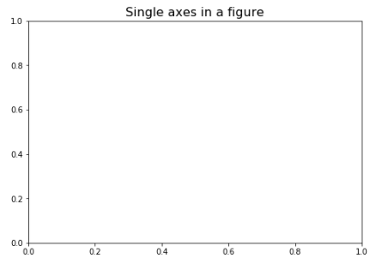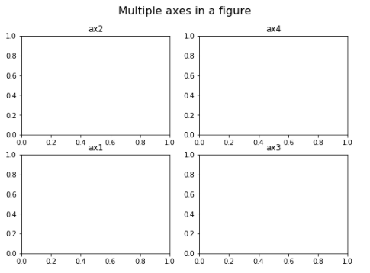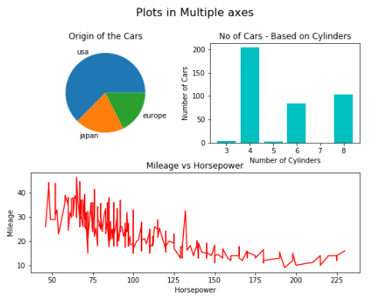
A plot comprises several elements such as title, label, axes, legend etc., that adds more meaning to the visualization. A sample representation of the plots is shown below.
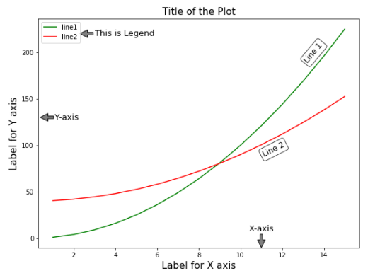
Matplotlib
- Matplotlib is one of the most basic and popular Python libraries used for data visualization. It was developed for imitating the plotting capabilities of MATLAB.
- matplotlib.pyplot is used for tow-dimensional graphics in python programming.
- It can be used in python shell, scripts, web application servers, and other graphical user interface toolkits.
- Matplotlib uses libraries such as NumPy as a base for underlying operations.

Plotting a line
- Define the x-axis and corresponding y-axis values as lists.
- Plot them on canvas using .plot() function.
- Give a name to x-axis and y-axis using .xlabel() and .ylabel() functions.
- Give a title to your plot using .title() function.
- Finally, to view your plot, we use .show() function.

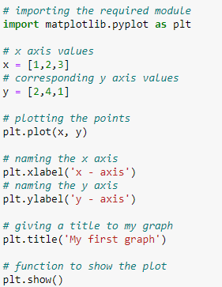

Plotting two or more lines on same plot
- Here, we plot two lines on the same graph. We differentiate between them by giving them a name(label) which is passed as an argument of the .plot() function.
- The small rectangular box giving information about the type of line and its color is called a legend. We can add a legend to our plot using .legend() function.

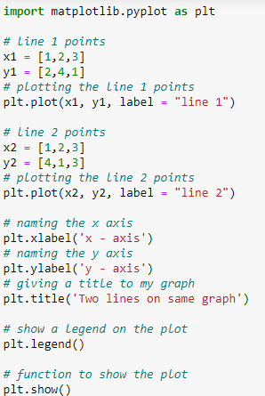

Customization of Plot
Several customizations can be done like
- setting the line-width, line-style, line-color.
- setting the marker, marker’s face color, marker’s size.
- overriding the x and y-axis range. If overriding is not done, pyplot module uses the auto-scale feature to set the axis range and scale.

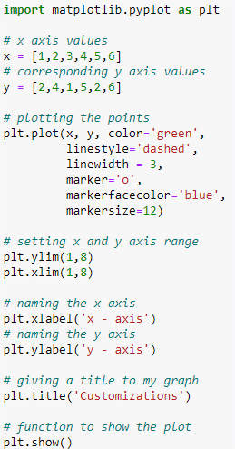

Bar Chart
- Here, we use plt.bar() function to plot a bar chart.
- x-coordinates of the left side of bars are passed along with the heights of bars.
- you can also give some names to x-axis coordinates by defining tick_labels

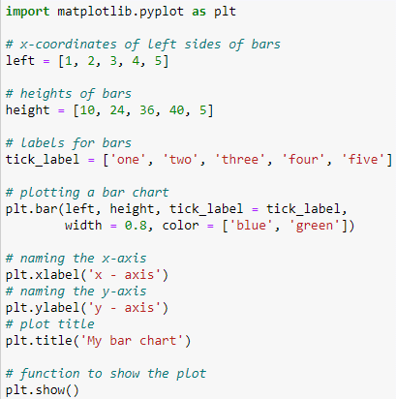

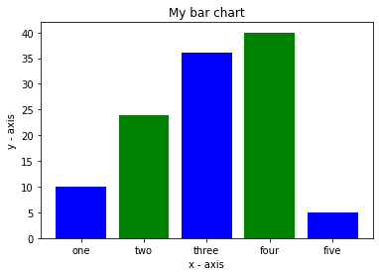

Histogram
- Here, we use plt.hist() function to plot a histogram.
- frequencies are passed as the ages list.
- The range could be set by defining a tuple containing min and max values.
- The next step is to “bin” the range of values—that is, divide the entire range of values into a series of intervals—and then count how many values fall into each interval. Here we have defined bins = 10. So, there are a total of 100/10 = 10 intervals.

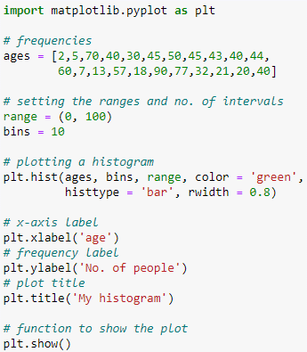

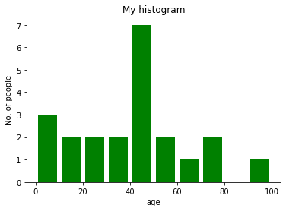

Scatter plot
- Here, we use plt.scatter() function to plot a scatter plot.
- As a line, we define x and corresponding y-axis values here as well.
- marker argument is used to set the character to use as a marker. Its size can be defined using the s parameter.

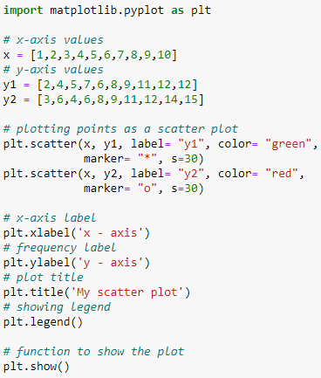
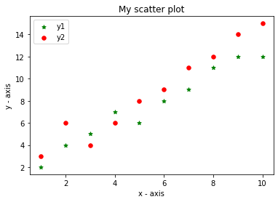

Pie-chart
- Here, we plot a pie chart by using plt.pie() method.
- First of all, we define the labels using a list called activities.
- Then, a portion of each label can be defined using another list called slices.
- Color for each label is defined using a list called colors.
- shadow = True will show a shadow beneath each label in pie chart.
- startangle rotates the start of the pie chart by given degrees counterclockwise from the x-axis.
- explode is used to set the fraction of radius with which we offset each wedge.
- autopct is used to format the value of each label. Here, we have set it to show the percentage value only upto 1 decimal place.
